Project Design Phase
Solution Architecture

Date | 25 June 2025
Team ID | LTVIP2025TMID59612
Project Name | SB Foods - On-Demand Food Ordering Platform
Maximum Marks | 4 Marks

Solution Architecture:
Solution Architecture bridges the gap between business needs and technical implementation. For the SB Foods application, the goal is to ensure a scalable, responsive, and secure full-stack food ordering system using the MERN stack (MongoDB, Express.js, React.js, Node.js), with clear data flow and modular components for users, restaurants, and administrators.
Objectives of the Architecture:
- Define how the application components interact across the tech stack.
- Ensure clear separation of concerns: UI, business logic, data storage.
- Enable smooth data flow between client, server, and database.
- Support future scaling (e.g., more users, multi-region deployment).
- Allow role-based access (User, Restaurant, Admin).
Architecture Layers and Components:
Layer | Components / Tools Used | Description
Frontend | React.js, HTML/CSS, Axios | User interface for all roles (User, Restaurant, Admin). Components include Login, Cart, Orders, Dashboard, etc.
Backend | Node.js, Express.js | RESTful API server that handles routing, authentication, product management, order processing.
Database | MongoDB (with Mongoose ODM) | Stores all structured data: Users, Restaurants, Products, Orders, Carts, Admin data.
Authentication | JWT (JSON Web Tokens) + bcrypt | Secure login for users, restaurants, and admin roles.
Hosting | Localhost (Dev) / Future: Vercel/Heroku/Render | Deployment of frontend and backend in cloud or container environments.
Dev Tools | Git, VS Code, MongoDB Atlas, Postman | Development and testing tools used for building and verifying the application.

Data Flow Summary
1. User Journey:
- User registers/login → token stored → fetches food listings → adds to cart → places order → order stored in DB.
2. Restaurant Journey:
- Logs in → lists or edits products → products stored in DB → can view orders made on their items.
3. Admin Journey:
- Logs in → views all users/products/orders → approves restaurants/products → manages categories/promotions.

Example - Solution Architecture Diagram:

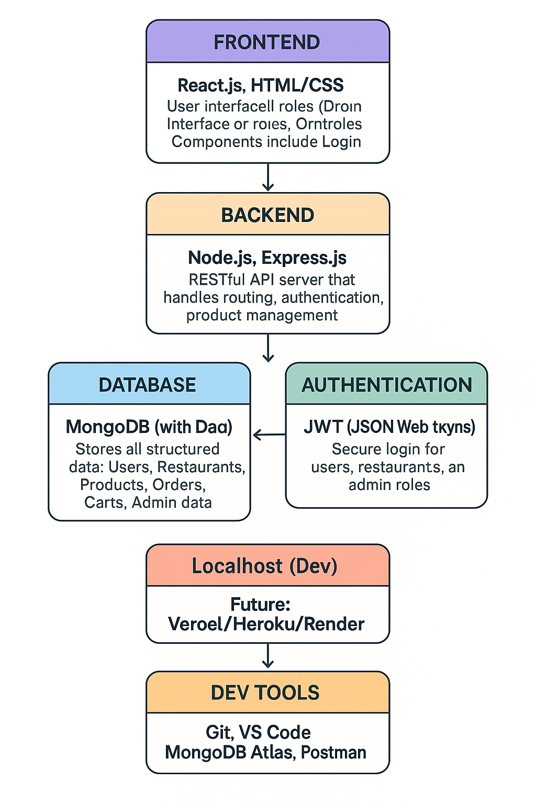
Figure 1: Architecture and data flow of the food ordering sample application
Reference: https://aws.amazon.com/blogs/industries/voice-applications-in-clinical-research-powered-by-ai-on-aws-part-1-architecture-and-design-considerations/

Features Defined in Architecture
Feature | Handled By | Status
User Authentication | JWT, bcrypt, Express.js | ✔ Implemented
Product Listings | MongoDB, React, Axios | ✔ Implemented
Cart & Order Management | React, Express, MongoDB | ✔ Implemented
Role-Based Access Control | JWT Middleware | ✔ Implemented
Admin Approval Flow | Admin Panel, DB updates | ✔ Implemented
API Layer Security | Auth middleware, CORS | ✔ Implemented
Scalability Provision | Modular Code, REST APIs | Scalable
Database Optimization | Mongoose ODM | ✔ Optimized

Notes
- The current design supports future enhancements like third-party payment integration, push notifications, and analytics.
- With MongoDB Atlas, the platform can be scaled vertically and horizontally based on usage.
- Role-based segregation ensures minimal coupling and better maintainability.

